Test Charter

**Charter** – Verify create request functionality

**Areas** –

- Sign in

-Create a new request

-Submit the request

**Test Environment and URL** –

Test Environment and URL | <http://18.156.17.83:9095/>

* Version Android 11.0
* Browser - Google Chrome
* Device - One Plus 8
* Tool | Lambda Test

**Start Date and Time** – 04.09.2022 | 15:30pm

**Tester** – Mateja Stojkovski

**Task Breakdown** –

* **Duration** – Short (20 min)
* **Test Design and Execution** – 10 min
* **Session Setup** – 5 min
* **Bug investigation and reporting** – 5 min

**Testing Notes** –

1. Sign in is successful
2. Navigated to the new URL: <http://18.156.17.83:9095/client/create-request>
3. Create request fill in all the fields
4. Click submit

**Bugs** –

* *Bug01* – Hamburger menu

Expected result: Menu should be remove after doing another function

Actual result: Menu doesn’t remove after doing another function

Tracking ID: 9923

* *Bug02* – Date can’t be clickable

Expected result: Should select date

Actual result: Can’t select date

Tracking ID: 9924

**Data files –**

Bug01

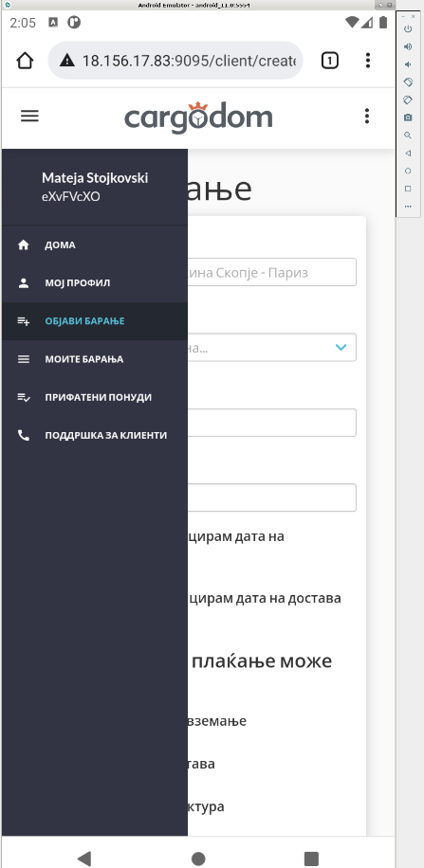

Bug 02

